29.24: a)
b) The current flows counterclockwise since its magnetic field must oppose the increasing flux through the loop.
c) 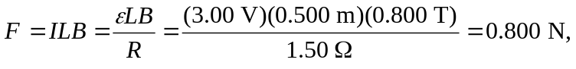 to the right.
d)
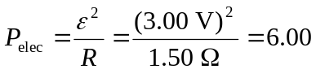 W. So both rates are equal.

